Fa’side Area Partnership
Invites you to our
ANNUAL PUBLIC MEETING
7th November 2017 at 7pm
Ross High School, Assembly Hall
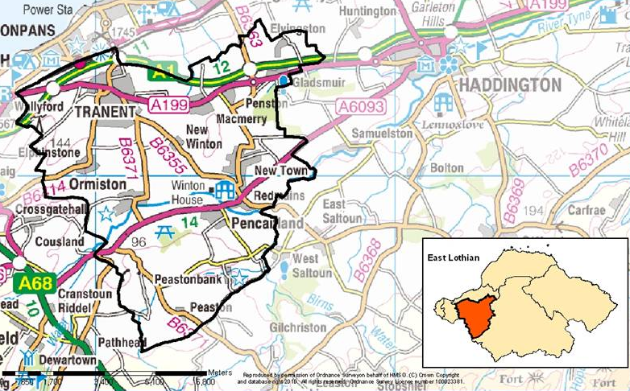

CALLING ALL FA’SIDE RESIDENTS

“A chance for you to find out what the Area Partnership has achieved and to have a say in our priorities for the future”

For more information on the Area Partnership go to www.eastlothian.gov.uk/ or contact us at
Fa’side-AP@eastlothian.gov.uk or on 01620 827871

