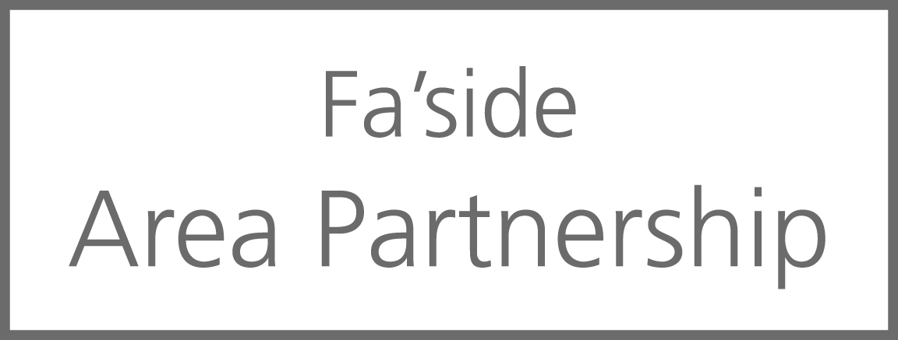
AGENDA

- Welcome to the Annual Public meeting and format BL/LH 7pm

- Area Partnerships and the East Lothian context AL 7.10pm

Area Partnership presentation (community groups) SD 7.15pm

- Review of our Area Plan and food/refreshments BL/LH 7.15pm

- SD 7.45pm

- Review of 2015/16 projects and food/refreshments All 8.10pm

- Summary of meeting, collect tallies and close SD 8.45pm

- Collection of feedback forms All 9pm

For more information contact Faside-AP@eastlothian.gov.uk or call 01620 827822

