Proposal to Install Safe Cycle storage in Haddington Town Centre.

Background
At the meeting of the Area Partnership on 21st October 2015 Haddington it was agreed to provide £5,000 funding from the existing Area Partnership Roads budget to spend on projects identified under the remit of the “East Lothian On the Move” project. This sum is match funded with a further £5,000 from the Scottish Government Smarter Choices Smarter Places programme. It is a criteria of this match funding that these monies are spent by the end of the 15/16 financial year.
The current HAL Area Plan also identifies the need to “install safe cycle storage in Haddington Town Centre” which aligns closely with the work of the On the Move project.

Proposal
Following work carried out by the ELC Roads Officer (Sustainable Travel) in consultation with the East Lothian Cycle Forum it is proposed to supply and install 22 cycle stands at 5 separate locations in Haddington Town Centre. The locations are:
- Outside Newtonport Surgery (3 stands)
- Court Street near the Old Procurator Fiscals Office (5 stands)
- High Street near the George Hotel (5 stands)
- High Street at Pedestrian Crossing Point in front of Boots (5 stands)
- Market Street at theTaxi rank (4 stands)
The cost to supply and install each cycle stand is £450 each bringing a total cost of £9,900 + VAT.
ELC Roads team have confirmed that this work can be completed within the current financial year and can be met in full from the £10,000 in funding already identified above.
Examples of this storage are shown overleaf.

This proposal links directly to the Area Plan under the Sustainable Travel Section – project ref ST2.

High Street near bus stops and pedestrian crossing point
5 stands to accommodate 10 bikes
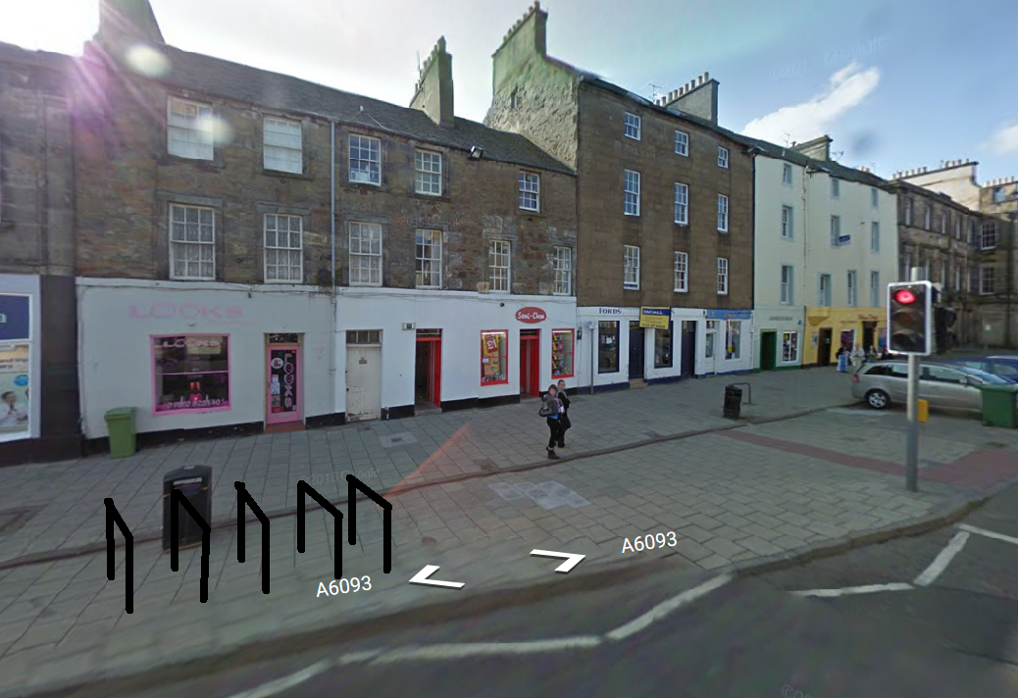

Example of cycle stands recently installed in Musselburgh High Street
