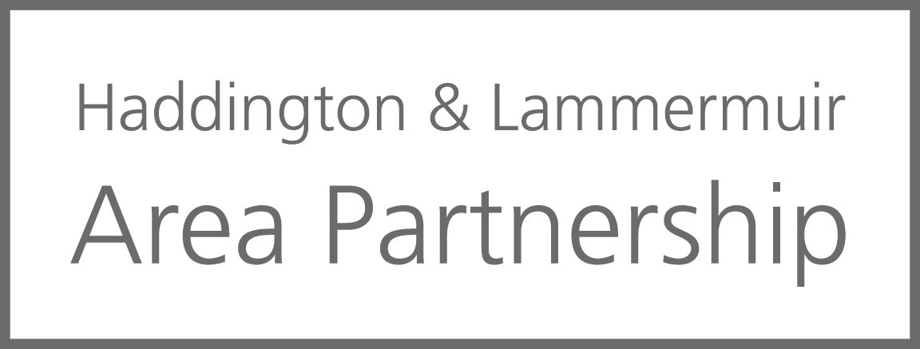

Proposal to allocate funds to Knox Academy Cycle Academy (KACA)
Background
KACA are currently running a Bike Maintenance class which is timetabled within the curriculum (6 periods a week) to pupils participating on the programme. Old bikes are recycled and then put back in to the local community via nurseries, primary schools and charities. This project will support pupils and help achieve a wide range of skills: personal development, life skills, active citizens, commercial and creative skills and preparation for work. KACA have spoken with Edinburgh College who are going to be an external verifier for pupils who will be working towards their City and Guilds in mechanics.
Pupils will also be coached in Bike Ability and will then build leadership skills by leading and delivering Bike Ability to local primary school children to develop their cycling skills and understand road safety.

The project will have cross curriculum learning through the whole school linking with CDT (maintenance), art (Designing), computing/ maths (Calculating distances, photos and videos) , P.E (Health and Wellbeing), English (diaries for evidence) and Geography (Mapping cycle routes) and will be aimed at offering pupils the opportunity to thrive, feel more valued, learn new skills and feel more confident learners. It will enable pupils to attain both the educational and personal development skills they will require for both further education and employability.
Current Project Budget
Total Project Value |  | Notes
Start-up equipment | £285.96 | Already paid by school
Fleet of Bikes | £2000.00 | Priced by Halfords
Bike Shelter (for 20 bikes) | £4752.00 | Bikedock Solutions
Tools/ Equipment/Components | £567.89 | Can get discount through East Lothian Outdoor Ed
Safety Gear (helmets,visibility vests, lights) | £250.00 | Priced by Halfords
Cleaning Equipment | £94.05 | Can get discount through East Lothian Outdoor Ed
Resources (Books/Certificates) | £100.00
Total | £8049.99

Proposal
Knox Academy is requesting that the Haddington and Lammermuir Area Partnership aid the funding for this project.
This proposal links to the Area Plan under Strategic Objective 1: PRIORITY 3 - Improving options for sustainable travel across our communities and also Strategic Objective 3: PRIORITY 1 – Supporting our Young People to fulfil their potential within the community

