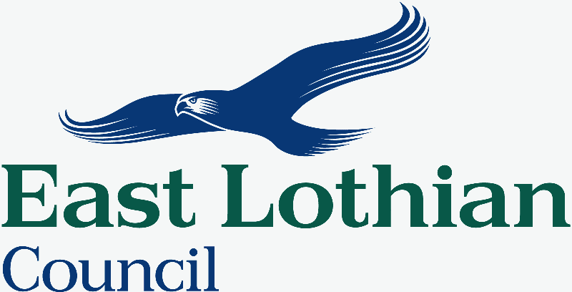

REPORT TO : fa’side area partnership

MEETING DATE : 3/11/15

BY : Town Centre Working Group

SUBJECT : Recommendations from Tranent Charrette

- PURPOSE
  - To provide recommendations to Fa’side Area Partnership following the publishing of the Tranent Town Centre Charrette Report.
- RECOMMENDATIONS
  - That Fa’side Area Partnership accepts the report from Kevin Murray Associates (KMA) on the Tranent Town Centre Charrette and endorses its recommendations as providing the foundation for a Town Centre Strategy for Tranent.
  - That Fa’side Area Partnership presents the attached report from the Tranent Town Centre Working Group to East Lothian Council with the request that work begins on the development of a Town Centre Strategy for Tranent, led by East Lothian Council’s Planning and informed by this report.
  - That the existing Tranent Town Centre Working Group (a sub-group of the Fa’side Area Partnership) becomes the basis of a Tranent Town Centre Delivery Team, charged with overseeing the development and delivery of the resulting Town Centre Strategy for Tranent, bringing in other delivery agencies and specialists as necessary to project manage the process.
  - That the Fa’side Area Partnership, through the Tranent Town Centre Working Group, continues to work towards the delivery of short term, smaller scale improvements (as identified in the Executive Summary, Appendix ¹) which are in line with the overall vision for Tranent contained in the Charrette Report while the Town Centre Strategy is being developed.
- BACKGROUND
3.1. The need for a focussed approach to regeneration in Tranent Town Centre was identified as a key priority for Fa’side Area Partnership from the outset – and a Town Centre Working Group was established, bringing together community representatives from the Area Partnership, ELC officers from Roads, Economic Development and Planning, Fa’side Councillors and a retired town planner providing independent expert advice and guidance.
3.2. Aware that there had already been a lot of consultation work done across the community in relation to what the issues/problems were in Tranent town centre (a summary of the previous community consultation is contained in Appendix ²) the focus of this group was on developing a strategic way forward for the town centre. When the Town Centre Charrette funding programme was launched in 2014 by the Scottish Government the decision was made to submit an application jointly between East Lothian Council and the Fa’side Area Partnership for an intensive design led engagement process that would bring together a wide range of stakeholders – professional, community, business etc – to develop a masterplan for the future of the area.
3.3. The brief drawn up by the Working Group defined the purpose of the Charrette as:
‘seeking the engagement of the community to explore design solutions to significant built environment, heritage and movement issues for Tranent town centre. Its results will support ELC’s implementation for a Conservation Area Regeneration Scheme (and subsequent funding) for Tranent town centre, Town Centre Strategy and also the preparation of the Local Development Plan.’
3.4. Through the Charrette process ELC asked the successful consultants to help all stakeholders to identify their vision for Tranent town centre focusing on:
- Built Environment – the structure, buildings and civic spaces of the town centre; how its overall environment can be improved as a space for people to use and enjoy more and feel safe within.
- Movement – a major issue previously identified by the community is the narrow and busy High Street - generating air quality, congestion and road safety concerns. To encourage better use of the High Street the charrette should consider alternative traffic and pedestrian routes in the area.
- Access – examining pedestrian and cycle access to the town centre with the aim of increasing permeability between civic amenities (e.g. library, sports centre) services (e.g. health centre and Council offices, schools) and the retail centre of the town.
- Economic Development - generating an environment in which businesses can confidently invest; identifying redevelopment opportunities within the town centre and opportunities to attract residents from the wider area into the town centre.
- Heritage – identification of the key heritage assets of the town centre and how they can be repaired, enhanced and evaluated to reinforce the identity of the town, particularly within the town centre conservation area.

3.5. Following the success of the bid to the Scottish Government a £30,000 contract was awarded to Kevin Murray Associates (KMA), in conjunction with Willie Miller Urban Design, Peter Brett Associates and ice-cream architecture, to deliver the Charrette.
It was agreed that the key outcomes would:

- underpin a Tranent Town Centre Strategy

- inform the Local Development Plan

- inform the implementation of a Conservation Area Regeneration Scheme for Tranent

- be integrated into the Area Plan being developed by the Fa’side Area Partnership

- provide a context for other actions taken by East Lothian Council in Tranent town centre while strategic plans for the town are developed.
3.6. The main body of the Charrette process took place in March 2015, with a follow up event in May 2015. During the 3 day event and follow up contact with the local community we received 150 contributions and 275 visits from various stakeholders. Additional feedback was sought from the wider public through an online survey open until the end of June, and a final meeting took place between the working group and KMA in July 2015. The Charrette Final Report was produced by KMA in August 2015 and is now publically available. See Appendix ³.
3.7. The Tranent Town Centre Working Group fully endorse the findings contained within KMA’s Tranent Town Centre Charrette Report. We feel that the outcomes and recommendations are all positive in nature and worthy of further investigation as the basis of a Town Centre Strategy for Tranent.
3.8. The Tranent Town Centre Working Group have also identified some of the proposals included in the report that we feel can be delivered quickly – actions that will not only contribute to the delivery of the overall vision for Tranent but which will encourage community members who took part, and others across the wider community about the worth of this exercise and our commitment to delivering results for the town.
3.9. An overview of this recommendations from KMA’s report on the Tranent Town Centre Charrette, the Working Groups considerations and proposals for taking the process forward can be found attached to this report. See Appendix ⁴.

- POLICY IMPLICATIONS
  - None at this stage.

- EQUALITIES IMPACT ASSESSMENT
  - This report is not applicable to the well being of equalities groups and Equality Impact Assessment is not required.
- RESOURCE IMPLICATIONS
  - Financial : None
6.2. Personnel : None
  - Other : None
- BACKGROUND PAPERS
  - Tranent Charrette Report: Executive Summary ¹ (Attached, as appendix 1).
  - A summary of the previous community consultation ² (Attached as appendix 2).
  - Tranent Town Centre Charrette Report by Kevin Murray Associates, available online: http://www.eastlothian.gov.uk/download/meetings/id/16854/tranent_town_centre_charrette-report_from_kevin_murray_associates

Author’s Name | Simon Davie/Kaela Scott
DESIGNATION | Area Manager/Local Community Planning Officer
CONTACT INFO | Mobile number: 07912 785 194
DATE | 27/10/15

