Understanding the Budgets Devolved to Area Partnerships
In December 2014 East Lothian Council devolved £1,250,000 to Area Partnerships to use in the 2015/16 financial year to meet the priorities identified in their Area Plans.
The budget allocated to the Preston Seton Gosford Area Partnership is outlined below.

As we approach the new financial year there is a need to ensure that everyone involved has a shared understanding of the potential uses of and constraints on these budgets.

We would like to invite you to an information sharing workshop for members of the Preston Seton Gosford and North Berwick Coastal Area Partnerships
Tuesday 21st April 6:30 – 9pm
Port-Seton Centre

The purpose of the evenings will be to:
- Highlight the purpose of devolving funds to Area Partnerships to deliver on local priorities;
- Give staff from Roads and Amenity Services the chance to inform Area Partnership members of their existing plans and priorities for expenditure in the local area and the operational limitations of these budgets;
- Allow Area Partnership members to develop a clear understanding of the constraints and opportunities presented by the devolved budgets, particularly in relation to the funds ring-fenced for amenity and roads services;
- Provide an opportunity for staff from Roads and Amenity Services to get a better idea of the priorities and types of projects/initiatives being explored for Area Plans;
- Establish a framework for Area Managers to manage the allocation of spending in line with the Area Plans;
- Ensure everyone involved has a shared understanding of the way the devolved budgets can be deployed.
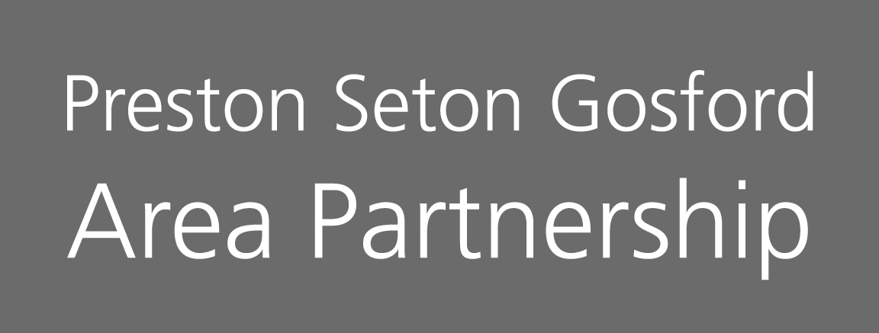
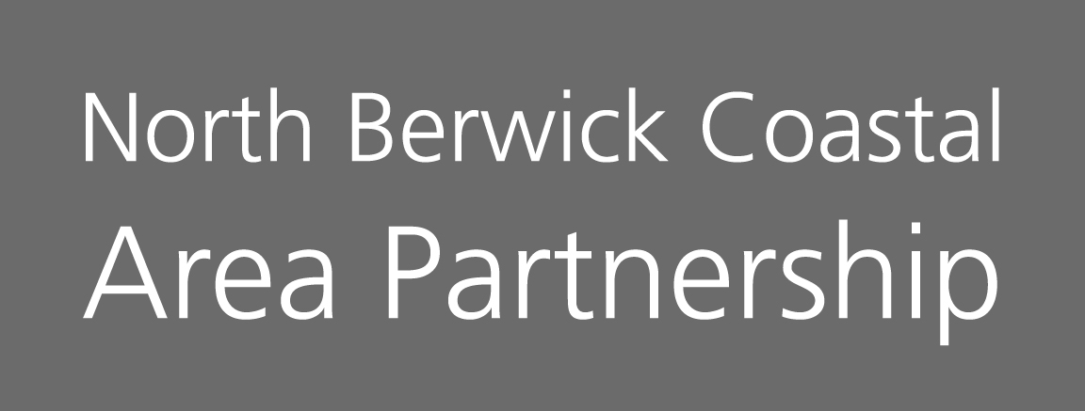
Please RSVP to PSG-AP@eastlothian.gov.uk by Friday 17th April

