**UNCRC Screening** **– Child friendly version**

This is a paper to decide whether or not to do a Children’s Rights and Well-being Impact Assessment for East Lothian Council’s Climate Change Strategy 2025-30. The Impact Assessment is a tool to help us understand if our plan is going to affect children’s rights. The Climate Change Strategy does not need an Impact Assessment because it does not have any detail about the plans that will affect children, so teachers and workers can make sure that no one is treated unfairly when those plans are started.

The Climate Change Strategy is our plan to adapt to climate change and reduce our greenhouse gas emissions. **Adapting to climate change** is making changes to what we do because climate change is making East Lothian warmer and wetter. **Greenhouse gas emissions** are particles of air which cause climate change. We create emissions by burning gas for heat and by driving cars. We need to have a plan for climate change because it is important for us and for our partners that we work as a team to stop climate change.

The Climate Change Strategy has 4 sections: **Governance**, **Assets**, **Services**, and **Place**. Each one has an **Outcome**, which is a goal that we want to achieve in the next 5 years.

**Governance** is how we act and why. **Assets** are the buildings, cars, and trucks we own that make greenhouse gas emissions. **Services** are the jobs we do. And **Place** is how we look after the people and the environment in East Lothian. 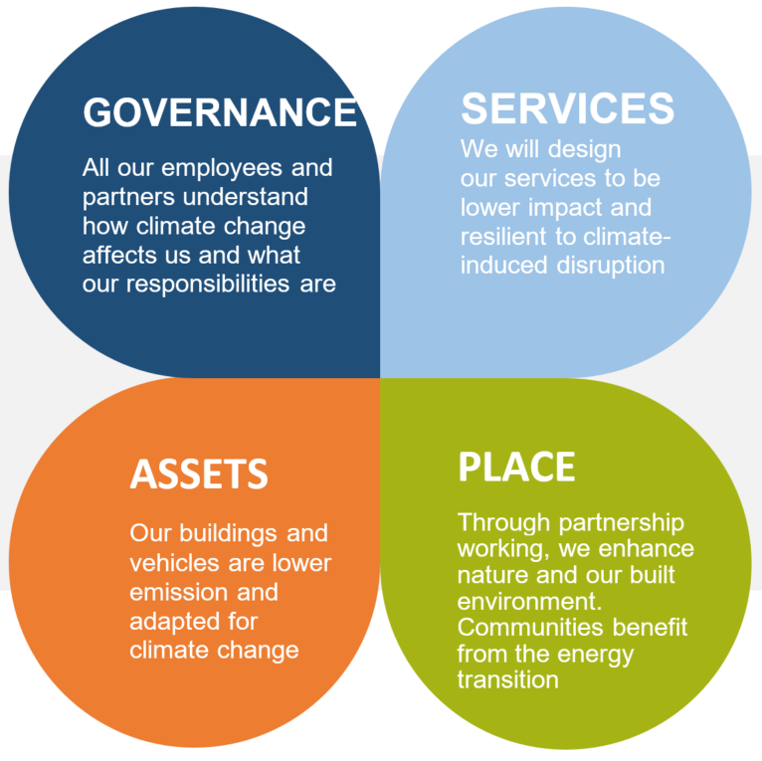

Most of our plans which affect children are in the **Services** theme. Some examples of these plans are teaching children more about the environment and making sure teachers are ready for climate change. These should have good effects on children because science says that children are happier and safer when other Councils make similar changes. Other plans in the **Governance** and **Place** themes include asking our partners to use less plastic and asking people to walk around schools instead of driving cars. These plans might affect children too and we think these will also be good changes.

The children who will be affected by our climate change plans are pupils in East Lothian schools and young children in our care. There will not be a type of children within that group who will be affected unfairly.