Supporting Good Decisions
Integrated Impact Assessment (IIA) Form
Promoting Equality and Human Rights,
Reducing Poverty

Title of Policy/ Proposal | Adult Carer Services – Service Specification
IIA Date | 5th December 2024, 1.30pm-3pm
Facilitator | Kate Thornback – Equalities and Engagement Officer
Lead officer | Maria Burton – Strategic Planning and Commissioning Officer - Carers
Sign off by Head of Service | 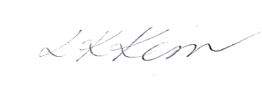 Laura Kerr General Manager Planning and Performance

Summary of Equality Impacts Note to reader: The impacts identified are a reflection of the experiences and knowledge within the room when the assessment was completed. Impacts outside of those identified may exist or arise over time.

Snapshot (references in the Evidence table): Evidence tells us that informal/unpaid carers are supporting people with increasingly complex needs in the community. The highest proportion of carers are women over the age of 50 and carers can be experiencing some continuing health issues of their own. A higher number of carers on lower incomes are in more intensive caring roles. Key impacts for all carers are on mental health and wellbeing, but those on lower incomes also reported having to cut back on essentials due to the costs of their caring roles and the increased cost of living.

Key protected characteristic groups disproportionately affected: Sex (women), age (over 50) and young adults (transitioning from youth support services to adult carer support services), disability (in the carer population and the cared-for population).
The disproportionate effects on people on lower incomes should also be considered in compliance with the Fairer Scotland Duty.

 | 0 - 6 months | 1 year | 3-5 years
Positive | There are opportunities to improve data reporting for both ELHSCP and the provider (changed reporting intervals). | More tailored data reporting could enable ELHSCP to make more timely decisions at an earlier stage of impact than in the past. | It is hoped that improved data reporting could also for swifter mitigation of any arising negative impacts over the course of the contract.
 | Focus on transition of young adult carers to adult carer services. | More young carers could transition from young carer support to adult carer support. | Young adult carers are better supported and more integrated into the carer community activities.
Negative | Waiting times increase (please note: current performance exceeds contractual requirements e.g referrals are contact in less that the specified time limits). | Waiting times exceed specified time limits due to population increase/demand | Population increases lead to the number of people that apply to use the service exceeding service capacity, extending waiting time limits for assistance, impacting negatively on the carer and the cared-for person in a range of ways.

Recommendations:
Consider in decision making whether the capacity being commissioned will meet the needs of the community if the number of carers increases at equivalent rates as 2011-2022 (last two Census dates, see section 5)
Explore the gap between the number of carers in East Lothian according to Census 2022 and those accessing services to ensure:
- There is no one that would like to request support not receiving it.
- That the number of people supported accurately reflects those that would like to be in contact with a carers support organisation.
Consider how the specification can support the transition of young adult carers to adult carer support services.

Wording
Improve the clarity of wording for the specification sections describing the levels and types of support locally e.g. ‘support for mental health/emotional support’ and carer’s wellbeing.
Consider including references in the specification to how ‘urgent’ referrals are triaged and the decision-making criteria for prioritisation.
Check whether Disclosure Act references require updating.
Consider how the needs of those in older age groups could be foregrounded in the wording of the specification or in appendices.

How we will monitor equality impacts:
The specification will require the provider to report:
- The wait times being experienced by service users on a quarterly basis.
- Numbers of young adults using their services (this could be compared with data from the provider for young carers to see if the numbers leaving support with young carers are transferring/seeing the support offer as relevant to them e.g. peer support groups).
- Number of people from ethnic minority backgrounds being supported.

What will change as a result of this proposal?

This impact assessment intends to review the proposed service specification for delivering adult carer support in East Lothian and discuss whether it includes the right elements and how well it can support service users and reduce inequalities for different groups.

The tender process will invite providers to bid for the contract to provide adult carer support in East Lothian, bids will be invited to meet an updated, more outcomes focused service specification. There is potential for this process to result in a change of provider for local carer support.

Briefly describe public involvement in this proposal (past, ongoing and planned)

Engagement with community groups including Dementia café attendants, members of Carers of East Lothians Carers panel and VCEL community first service users has given information to inform the development of the service specification used for tendering. An open invitation was shared with all carers registered with the current provider to give feedback on the difference support makes and any gaps.

Is the proposal considered strategic under the Fairer Scotland Duty?
Yes.

Participants of the IIA
Name/Role | Job Title
Maria Burton (Lead Officer) | Strategic Planning and Commissioning Officer
Kate Thornback (Facilitator) | Equalities and Engagement Officer
Diane Rodgers | Community Care Worker (carers)
Marie Prior | Young Carers Service Co-ordinator
Jess Wade | Chief executive Carers of East Lothian
Sofia Latif | Chief executive Milan senior welfare organisation
Robin Grant | Carers panel member
Dorothy Bartholomew | Carers panel member

Evidence available at the time of the IIA
Evidence | Available – detail source | What does the evidence tell you about different individuals and groups who may be affected by your proposal?
Data on populations in need | Scotland’s Census 2022 - Health, disability and unpaid care | Scotland's Census – Figures 7 - 9  Carers of East Lothian – COEL (current service provider). The comment was provided verbally during the IIA but is supported by their service user data.  East Lothian HSCP JSNA June 2023 | East Lothian Council | There were 627,700 unpaid carers in Scotland in 2022, an increase of 27.5% since 2011.  Over the same period there was a 15.7% increase in number of people with a health problem or disability.  The number of carers in East Lothian was 13,147.  Carers that approach COEL chiefly approach them for assistance related to a person with physical disabilities or dementia.  Our population is changing and people are living longer  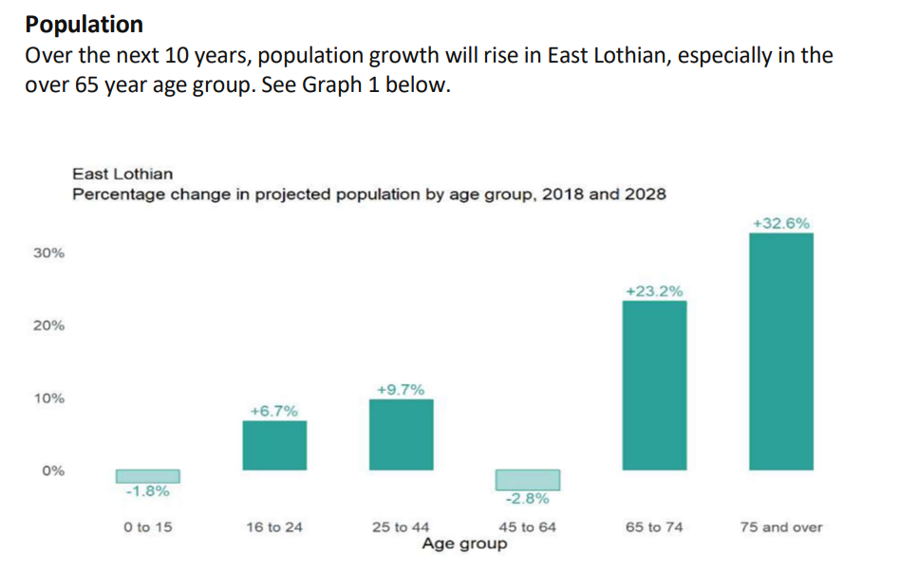  From 2018 to 2043, East Lothian’s population is predicted to increase by a further 12.8% reaching a peak of 121,743 and will grow at faster rate than Scotland as a whole.  Increases in the population and particularly in the ageing population has potential to impact carer support service demand.
Data on service uptake/access | Contract monitoring data from the current service provider. | The current provider actively supports around 1500 carers and shares information and advice with over 6000 East Lothian carers.
Data on socio-economic disadvantage e.g. low income, low wealth, material deprivation, area deprivation. | East Lothian HSCP JSNA June 2023 | East Lothian Council  www.gov.scot/publications/carers-strategic-policy-statement-draft-consultation/  State of Caring survey | Carers UK | East Lothian has 8 data zones within the 20% most deprived areas in Scotland (according to the Scottish Index of Multiple Deprivation – SIMD).  The majority of SIMD deciles (1 (least deprived) to 7 and 10) have decreased in population percentage (between 2016 and 2021. Two SIMD deciles (8 and 9) have increased in population percentage, with SIMD 8 showing the largest change of all categories.  Evidence shows 47% of carers in the most deprived areas care for 35 hours a week or more, almost double the level in the least deprived areas.  Carers are finding it increasingly difficult to afford day to day living costs, with the worry and anxiety of this affecting their mental health and wellbeing  28% are cutting back on essentials like food and heating.
Data on equality outcomes | Scotland’s Census 2022 - Health, disability and unpaid care | Scotland's Census – Figure 8  soc23-health-report_web.pdf | Data shows the biggest group of carers are aged 50 or over and 58.8% are female and the biggest increase was in the 50-64 age range.  29% of respondents to the State of Caring survey 2023 stated they have a disability. This means many carers will have complex needs of their own.
Research/literature evidence | National Carers Strategy - gov.scot (www.gov.scot) | “Carers' individual needs and the impact of caring depend on all sorts of factors such as their age, health and ethnicity, and their support networks of family and friends. For example, minority ethnic carers face the same challenges as all carers, but also face additional barriers, for instance cultural barriers, stereotypes and language which can increase the chances of poorer health, poverty and social exclusion. The level and type of care provided is also a major factor. There are very different physical and emotional pressures from supporting someone with addiction, a mental illness, a physical disability or learning disability, or a progressive condition or terminal illness.”
Public/patient/client experience information | Feedback from engagement to inform service specification | The main reasons carers are accessing support are carer wellbeing, finance/benefits and short breaks/respite.  People with experience of carer support were very positive about the impact of this support from the local carers organisation.
Evidence of inclusive engagement of people who use the service and involvement findings | We engaged with local carers through existing supportive relationships with the intention that carers would be more comfortable sharing their views in this way and with workers who understand their communication needs.  Carers also had the option to share information by email.  Service users were asked:  - What are the most important aspects of the service?  - Where are the gaps?  - What difference does good support make/ has good support made? | Support must be personalised to work for the carer and be delivered in a way that suits individual preferences and communication needs.  Workers should provide support in a time, place and manner that suits the individual, support will be offered based on what is happening and most important to the carer at that point in time.
Evidence of unmet need | Scotland's Carers Update Release March 2024 - gov.scot | Estimates of unpaid carers in the Scottish population vary between 15-20% with higher percentages in certain groups, for example 26% of females aged 55-64 provide unpaid care.  2022 census data showed 13,147 carers in East Lothian which is lower than other sources estimate (based on 15% estimate that number would be 16,867). This may indicate that caring is under-reported on the Census in East Lothian.  The current East Lothian carers service provider is in touch with around 6000 which indicates around 7000 unidentified carers, however we know that carers look for support from informal networks and community before looking for more formal supports.
Good practice guidelines | Carers' charter - gov.scot  Support for adult carers | Health topics A to Z | CKS | NICE | “extends and enhances the rights of carers in Scotland to help improve their health and wellbeing, so that they can continue to care, if they so wish, and have a life alongside caring.”
Risk from cumulative impacts (Head of Service to answer) | Integration Joint Board attendance. | This is a positive service specification and no risks additional to those identified have been noted.
Other (please specify) | n/a
Additional evidence required | n/a

6. What impacts were identified and which groups will they affect? Please include suggested mitigations for negative impacts and actions to maximise positive impacts.

Equality, Health and Wellbeing and Human Rights | Affected populations
Positive  - Emphasis has been placed on the providers ability to deliver a locally based service and make use of other local community spaces improving physical accessibility and reducing peoples need to travel (clause 4.2)  - Contracts and delivery will focus on quality rather than cost and collaboration rather than competition (clause 1.1) this is reflected in the outcomes focus of the specification as well as the proposed changes to reporting to focus on service and personal outcomes | - Unpaid carers,  - Carers with barriers to travel  - Unpaid carers, service will be focused on quality of support and recognition of what is most important to them, what difference support will make
Negative  - The specification wording does not fully reflect the overall impact on mental health that caring can have and the skills required from the provider to deliver support services sensitivity.  - Young adult carers could be lost at the transition point (e.g. not take up support) between services for young carers and adult carers at important point in their life. Potential for this to affect opportunities for learning work and future development  - The specification wording does not fully reflect how much support is provided to different groups, for example carers of older people and people with dementia (both of which are increasing).  - The diversity of the workforce of the provider should aim to represent the diversity of the population.  - The specification sources an adequate level of support to meet current requirements but does not account for potential future increases in demand.  - The specification does not outline what ‘urgent’ means in terms of prioritising some referrals over others. | - Unpaid carers  - Young adult carers.  Young carers typically access support from a specialist worker with Bridges Project. It was suggested that this provider work with the incoming provider of adult carer support to become more accessible to Young adult carers  Potential to provide all YC with a letter giving them contact details for carers org if they need it.  Contract monitoring will include uptake of carer support by different demographics, supporting main ones but focusing on widening access to under represented groups (clause 2.1)  - Within the specification that provider will aim to make progress towards this where possible while maintaining appropriately skilled and experienced workforce  - Monitor demand and wait times through contract monitoring (this is required under Key Performance Indicators)  - Statement to reflect how this decision making will lead to equity of access is needed and will be added.

Socio-Economic | Affected populations
Positive | n/a
Negative | n/a

7. Is any part of this policy/ service to be carried out wholly or partly by contractors and if so how will equality, human rights including children’s rights, environmental and sustainability issues be addressed?

No

8. Consider how you will communicate information about this policy/ service change to children and young people and those affected by sensory impairment, speech impairment, low level literacy or numeracy, learning difficulties or English as a second language? Please provide a summary of the communications plan.

IIA will be published online, communications plan not required as impact assessment to inform specification for service.

9. Additional Information and Evidence Required?

10. What actions have been, or will be, undertaken and by when?
Specific actions (as a result of the IIA which may include financial implications, mitigating actions and risks of cumulative impacts) | Who will take them forward (name and job title) | Deadline for progressing | Review date
IIA Review | Kate Thornback, Equalities and Engagement Officer, ELHSCP |  | January 2026
(Things to monitor)  - The demand on service and associated wait times being experienced by service users on a quarterly basis.  - Numbers of young adults using their services (this could be compared with data from the provider for young carers to see if the numbers leaving support with young carers are transferring/seeing the support offer as relevant to them e.g. peer support groups).  - Number of people from ethnic minority backgrounds being supported. | Maria Burton (Strategic planning and commissioning officer, carers)  Maria Burton  Maria Burton | June 2026 (if there is a negative impact we will be taking action as early as possible after quarterly reporting)  June 2026 (after 1 year of contract)  June 2026 (after 1 year of contract) | January 2026

11. Are there any negative impacts in section 6 for which there are no identified mitigating actions?
No

