East Lothian Council Climate Change Strategy 2025 – 2030

# Contact: climatechange@eastlothian.gov.uk

# Strategy Purpose & Structure

The East Lothian Council Climate Change Strategy 2025 – 2030 is our plan to respond to the climate emergency. It outlines how we will enhance our response to the effects of climate change and how we will accelerate emissions reduction. We must reach net zero emissions by 2045, and this document is a guide to explain how we will set ourselves up for success in achieving this target. It explains how we are approaching climate adaptation and mitigation as an organisation, and it also sets actions for individual services which support this approach. This document will not be able to cover everything the Council does in response to climate change, but it sets out the changes we will make to make climate action a part of everything we do.

The Strategy begins by reviewing the background to climate action, including the successes of the previous Climate Change Strategy 2020 – 2025. It also explains the science of climate change and the predicted climate impacts of climate change in East Lothian. It then explains why we must act, including policy drivers such as the UK’s nationally determined contributions, Scotland’s target of net zero by 2045, and our own declaration of a climate emergency.

It then sets out our organisational approach to climate adaptation and to climate mitigation. The principles that are outlined form the basis of the entire plan that follows. Our corporate approach to climate adaptation is to follow an urgency-based framework, where we address the most immediate risks to our operations. Our corporate approach to climate change mitigation is to follow the mitigation hierarchy, where we look to avoid making emissions as a top priority, reduce emissions if this is not possible, and replace high-emissions activities with low-emissions technologies. Offsetting is not currently part of our strategy, because there is still scope to reduce our own emissions.

The bulk of the Strategy explains how we will make our different operations and functions climate positive. These functions are divided into 4 themes: Governance; Assets; Services; and Place. Each theme has an outcome statement, which is what we aim to achieve by 2030. The themes are further divided into Focus Areas, which describe how we will improve the resilience and sustainability of specific functions and areas of influence. See the diagram below for a visual overview of the Strategy's structure:

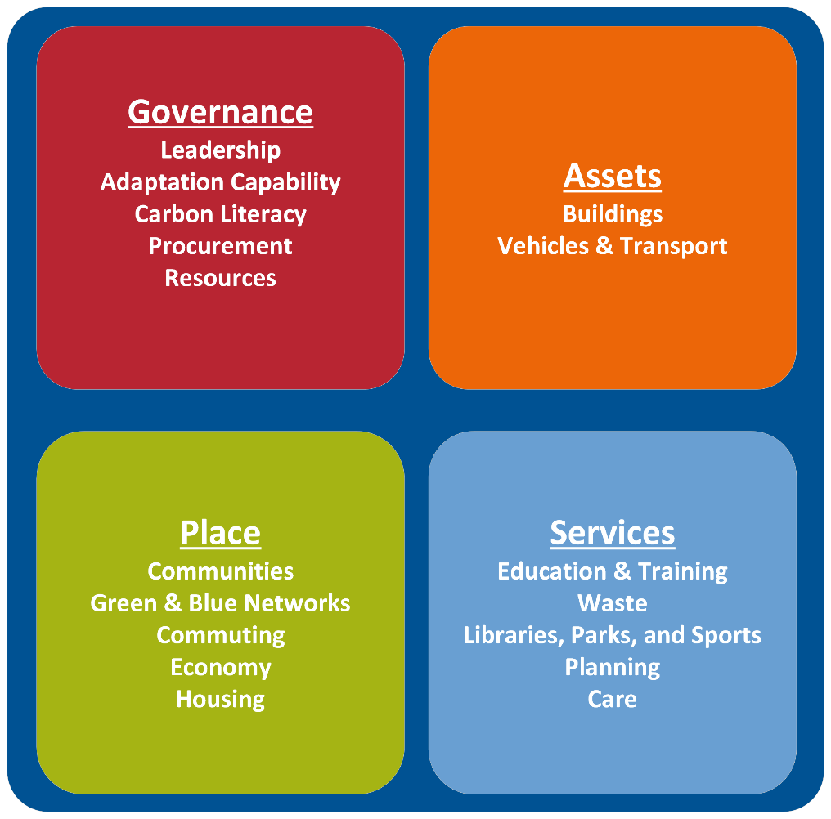

Communications is the golden thread throughout the Strategy. There will be an inset box in each Forus Area of the Strategy to explain how we plan to communicate our plans and improve understanding of the need to act. It is important to explain to people both within and outwith the Council what climate action we are taking, why we are doing it, and how they participate. There will be a ‘Make a Difference’ communications campaign to support the Climate Change Strategy 2025 – 2030.

# Climate Change

## The Greenhouse Effect

Climate change is the shift in weather patterns caused by global warming and greenhouse gas particles in the atmosphere. These weather patterns include higher average temperature and more intense rainfall. Greenhouse gases also make the seas more acidic and reduce air quality. These shifts are extremely dangerous to humans because our way of life depends on a narrow window of climatic conditions that is now being disrupted. The world ocean and our natural environment have absorbed the impacts of climate change, but continued industrial exploitation means that planetary systems may soon reach ‘tipping points’ where they harm rather than help humans. Therefore, what is occurring is a climate and nature emergency.

Greenhouse gases are emitted by human activities which burn carbon-based fuels like petroleum and natural gas, which are called ‘fossil fuels.’ These activities might include driving petrol cars or using gas boilers. Greenhouse gases can also come from agriculture and from industries which make goods. The main greenhouse gases are carbon dioxide, methane, and nitrous oxide.

Climate change is a difficult issue to govern because it is a global issue – emissions generated elsewhere will affect us in East Lothian and vice versa. The rapid industrialisation which is enabled by burning fossil fuels also generates significant wealth for certain countries, while others have not been able to see those benefits. Countries that have not benefitted from industrialisation are the most vulnerable to the effects of climate change. Most greenhouse gases were emitted in the past, and we are already locked into a significant amount of global warming. However, it is a critical global imperative to cut emissions and adapt to climate change rapidly to avoid costly and devastating levels of disruption. Every fraction of warming that we can avoid will save lives.

## Drivers for Change

The science behind climate change is unambiguous. It is caused by human activity and we must cut emissions rapidly to avoid a global climate breakdown. We acknowledged this when we declared a climate emergency in 2019. This prompted the creation of the East Lothian Council Climate Change Strategy 2020 – 2025. This strategy must be updated to reflect the latest guidance and developments and to further accelerate emissions reductions. This document is our guide to accelerating climate action and preparing to meet our 2045 net zero target.

The United Kingdom is a signatory to the Paris Agreement, which was signed in 2015 and commits us to achieving net zero emissions by the year 2050. Scotland has gone one step further in the Climate Change (Emissions Reductions) (Scotland) Act 2019 and committed to reaching net zero by 2045. We as a local authority must align with and contribute to achieving these targets. As it stands, we have to contribute to a national target of cutting 75% of our 1990 emissions levels by 2030, but this target was determined infeasible and will be altered in 2024. We will now set our own targets based on our current trajectory of emissions reduction, aligning with the Scottish Government’s approach where possible.

This Strategy is also aligned with the Scottish National Adaptation Plan 3, which was adopted in September 2024. We have focussed our adaptation actions on the relevant Outcomes of the Plan from the outset of the Strategy’s development. This includes identifying nature-based solutions to climate impacts, working with communities to improve their resilience to climate change, and delivering our services accounting for extreme weather and climatic shifts.

Adaptation to climate change and emissions cuts must be made in a challenging time for public finances. Inflation and the cost-of-living crisis, with all the pressures they bring, restrict our ability to undertake unilateral transformative change. However, we also recognise that the cost of inaction will be far greater if we allow climate change to wreak havoc on our area and operations.

# Previous Strategy (2020 – 2025)

The East Lothian Climate Change Strategy 2020 – 2025 was one of the first climate strategies passed by a local authority. It was innovative for its clear, well-defined outcomes and Council-wide approach to climate action. It balanced whole-Council policies with actions for individual services. The Strategy had a robust process for collecting data annually and reporting it to Council, which tracked progress well and kept climate change on the agenda.

Many of the previous Strategy’s aims were achieved. A significant portion of our fleet now is now low- or zero-emissions, all of our waste is diverted from landfill, and new schools are built to a high standard of energy efficiency.

By the end of the Strategy cycle, the Council’s Scope 1 and 2 emissions were reduced by around 20%. However, we now robustly report on emissions from staff commuting, which are higher than previously thought. This is a still a positive development because we better understand and report on our emissions, and we can now identify our priorities for climate action going forward. The 2020-2025 Strategy laid the foundations for well-integrated climate action and robust reporting, and it allows us to set clear targets for the coming Strategy cycle. The diagram below shows our emissions over the 2020-2025 Strategy's lifetime:

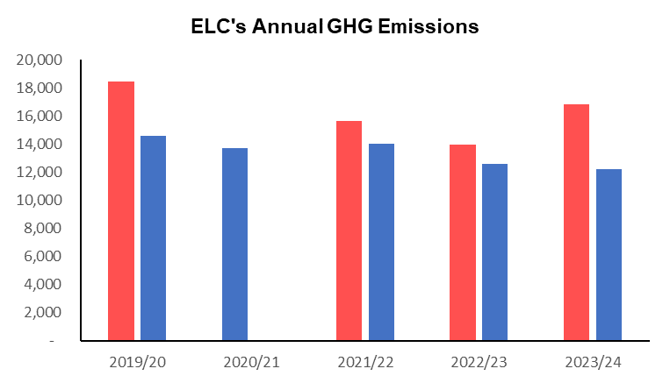

# Strategy Development

This Strategy was developed beginning with the Action Plan. Actions were co-developed with the services responsible for delivering them and are based on recommendations by Audit Scotland, Sustainable Scotland Network, and actions from the Climate Change Strategy 2020-2025. New actions were also created to capture the excellent work on climate action being done across the Council already. Actions were written using logic modelling, where the action is based on the services’ available resources and directly linked with a desired outcome. Actions are measured quantitatively, with either a yes-no answer or a numerical value so that year-on-year progress can be tracked objectively. The Strategy text was written to capture the main parts of the Action Plan and link these actions to our overall approach. The document is therefore the guide to our whole-Council approach and a catalogue for individual services’ climate action.

Consultation will be undertaken in autumn 2024. There will be several sessions for Council officers to respond to and feed back on the Strategy, since the objectives are theirs to fulfill. There will also be 6 in-person sessions in the 6 East Lothian Area Partnership geographies, where the public can participate in facilitated discussions with our Sustainability & Climate Change Officer, who is leading the development of the Strategy. Views will also be collected online on the East Lothian Consultation Hub.

# Our Plan

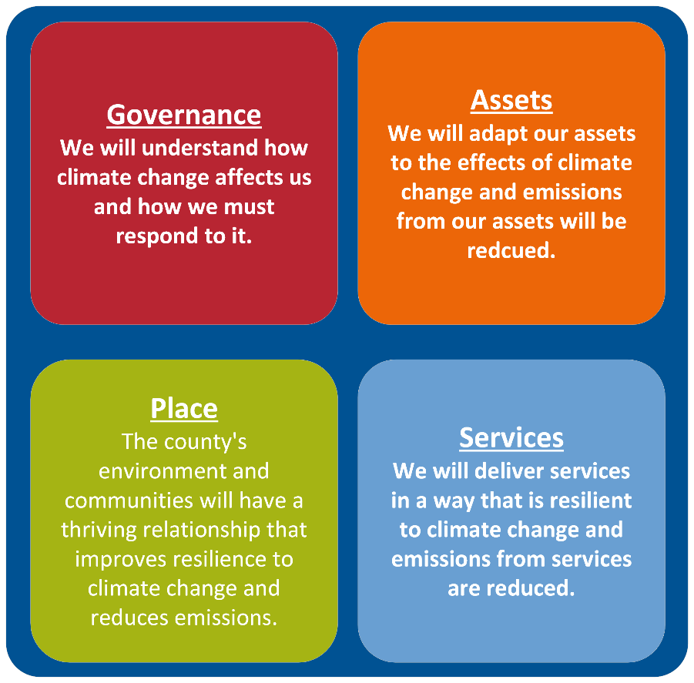

The above diagram describes desired outcomes for each of the 4 Themes.

## Climate Change Adaptation

Climate change is already affecting us, and we must adapt to sustain our livelihoods. Scotland is experiencing average temperatures about 1.5 degrees Celsius above last century’s average and this is causing hotter, drier summers and warmer, wetter winters. Globally, climate change is increasing the frequency, severity, and duration of extreme weather events. These events cause migration of people and disruption to global supply chains, which we can address by diversifying and localising our supply chains.

In East Lothian, the most prevalent climate risks we are already experiencing locally are flooding, coastal erosion, and heat. These climate risks are at the forefront of our minds when we adapt to climate change.

These are physical risks to climate change, but there are also transition risks. These are the risks posed by not being prepared for a climate-ready world, such as lacking the grid capacity to electrify our fleet. We can address transition risks by allocating space, resources, and infrastructure for what will be the new normal ways of living and working in a climate-ready world. Therefore, our adaptation planning will also seek to prepare us to thrive in this changed world.

We will adapt using the Climate Change Committee’s Risk Assessment, which used an urgency-based framework, to assess the climate adaptation actions that will provide the greatest benefit to resilience in the next 5 years. We will improve our understanding of how climate change affects our operations and area, and we will choose the most effective and lowest-emissions adaptation method appropriate for that sector. The following diagram is a flowchart to visualise how the assessment asks questions to identify the most urgent climate risks.

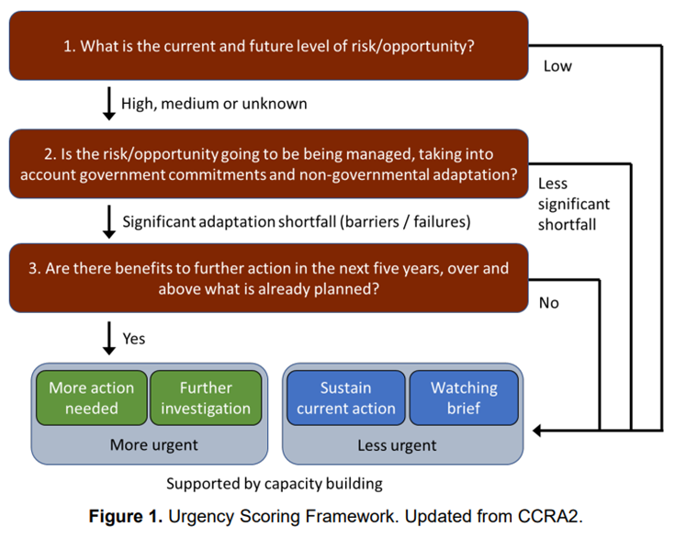

## Climate Change Mitigation

Mitigating climate change is about reducing our emissions so that climate change is less severe. The faster we reach net zero, the less climate change we will have to adapt to. We must cut our emissions reliably and effectively within a constrained budget, so we will adapt the mitigation hierarchy to appropriate Council operations. By looking to avoid creating emissions in the first place, we will align emissions reduction with the need to focus on core Council services. The following diagram is called the 'Mitigation Hierarchy' and visualises which climate mitigation actions are the highest priority.

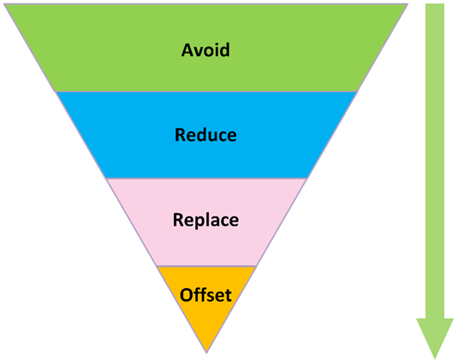

We will also look to reduce the emissions we produce at source by improving the efficiency of our operations. This can be achieved by using more efficient technologies, or by thinking logistically about how we work & travel to minimise the emissions we create from our activites.

We must achieve net zero emissions by 2045, along with the rest of Scotland. To ensure we reach this goal, we must set interim targets that are credible, robust, and aligned with a national strategy. However, there is uncertainty regarding how we achieve decarbonisation nationally, and many of the changes that will make the biggest difference to us as a local authority are national decisions. We will therefore set targets for 3 different scenarios at varying levels of ambition. All scenarios are data-based and feasible based on prior cuts to emissions and our projected levels of emissions over the next 5 years.

### Transformational

In this scenario, it is recognised nationally that reaching net zero will shortly be a medium-term target. Grid electricity decarbonises quickly because national projects come online, and we invest in supplying our own-zero emissions energy. We will reduce emissions using reliable methods and we are able to produce our own energy, which improves resilience and reduces cost in the medium-term. We are able to set ourselves an absolute target of cutting 1,100 tonnes CO2e per annum, which is approximately equal to year-on-year changes prior to 2024.

The main risk to this scenario is financial and staff resource. Due to funding crises, there would need to be significant external funding to enable us to think about energy in the medium-term. Barriers to decarbonisation of our fleet, such as cost and insurance, will need to be overcome. Achieving these ambitious targets is also likely to depend on large renewable developments coming online, which themselves depend on upgrades to the national electricity grid. However, meeting our transformational targets is ultimately lower-risk and lower-cost because we will be more likely to reach net zero emissions by 2045 and will have less climate change to adapt and respond to.

Our emissions budget in this scenario is 67,800 tonnes CO2e and our interim targets are:

| Year | Emissions in tonnes CO2 equivalent |
| --- | --- |
| 2024/25 | 15,760 |
| 2025/26 | 14,660 |
| 2026/27 | 13,560 |
| 2027/28 | 12,460 |
| 2028/29 | 11,360 |

### Continual

These emissions targets assume that the rate at which our emissions have been falling is accurate, but the starting point should have been higher due to under-reported emissions from commuting. In this scenario, there is limited progress mitigating climate change nationally. We will continue to prioritise electrification and efficiency where possible and we will aggressively progress energy use reduction, which also saves costs. Completing the actions in our Action Plan proves effective and we are able to accelerate emissions reduction compared to our expected trajectory.

In this scenario, resources remain our biggest risk. Because we are not able to meet our ambitions of energy independence, we may also find it more challenging to continue our progress reducing emissions while continuing to deliver statutory services. While this scenario represents improvement over business-as-usual, the rate of progress tapers off and challenging residual emissions remain by 2030, which means we will need more adaptation to climate change and redoubled efforts to reach net zero in the subsequent 15 years.

Our emissions budget for this scenario is 73,360 tonnes CO2e and our interim targets are as follows:

| Year | Emissions in tonnes CO2 equivalent |
| --- | --- |
| 2024/25 | 15,950 |
| 2025/26 | 15,210 |
| 2026/27 | 14,580 |
| 2027/28 | 14,050 |
| 2028/29 | 13,570 |

### Business as Usual

These emissions reduction targets are modelled on the assumption that, because emissions from staff commuting are higher than previously estimated, our emissions reduction has not been as substantial as suggested. In this scenario, funding crises in the public sector continue and the need to deliver statutory services at the lowest possible cost takes precedence over value. We will carry on making our operations more efficient, thinking about mitigating climate change in various operations, and making incremental changes. This model assumes that grid electricity will decarbonise gradually as it has in prior years. Our rate of emissions reduction will slow dramatically by 2030 if this scenario is realised.

Our growing estate and inadequate decarbonisation of grid electricity are the risks to meeting these targets. If there is not enough renewable energy capacity to meet the demand for electricity, there is a risk to meeting these targets despite improving electrification. We may be able to realise this scenario with relatively minimal investment, but this will also create risk. If we are unable to meet or exceed these targets, we will face a significant challenge to achieve net zero emissions by 2045 and will have to adapt even more to our changed climate.

Our emissions budget for this scenario is: 75,890 tonnes CO2e and our interim targets are as follows:

| Year | Emissions in tonnes CO2 equivalent |
| --- | --- |
| 2024/25 | 15,950 |
| 2025/26 | 15,490 |
| 2026/27 | 15,120 |
| 2027/28 | 14,800 |
| 2028/29 | 14,530 |

# Governance

Outcome: We will understand how climate change affects us and how we must respond to it.

Climate actions under the Governance theme are those that improve our understanding, reporting, and commitment to climate action. These actions will help us be a climate-ready and climate-positive organisation. The outcome means that, by 2030, we should have a deep understanding of how we are contributing to climate change and how it affects our service. We should also be working to address both of these issues and be robustly explaining & reporting how we are doing so.

## Focus Area: Leadership

The public sector is tasked with leadership in the climate emergency, and local authorities are the vanguard of that effort. Communities and the governments look to Councils to implement climate action in the first instance. They are responsible for about 2% of emissions in the UK, but according to the Carbon Literacy Project, can have a much wider influence in the area.1

We will take on this responsibility by leading by example. We will improve our annual climate change reporting by adopting interim emissions reduction targets and identifying where emissions savings came from in reports to Council. We will also produce several documents, including a food-growing and a heat and energy efficiency strategy, which instruct the region’s approach to reducing emissions and becoming more resilient to climate change. We will also adopt clear and robust lines of communication to bring our community and partners with us on our mission.

*Communications Objectives: Sustainability will be part of our everyday thinking as a Council. Residents, partners, and staff should clearly understand what our sustainability goals are and how we plan to get there. Council staff, reports, and press statements should clearly link our work to climate outcomes where appropriate and should use consistent and accurate language.*

## Focus Area: Adaptation Capability

Adaptation capability is a framework developed by the charity Sniffer and used by Adaptation Scotland to support public sector bodies. By completing tasks associated with the framework, we become more mature in our capability. This will improve how prepared we are to deal with the risks posed by climate change. The effects of climate change are accelerating – we are already locked into significant sea level rise and more extreme weather. Having this improved capability means we are more prepared for and resilient to these effects.

We will aim to reach the advanced stage (Stage 3) of the Adaptation Capability Framework by 2030. Our capability will be assessed annually at workshops, and the results of these workshops are one of the Top 50 Indicators of Council performance. We will look to enhance our capability by taking actions which integrate thinking about adaptation throughout the organisation, from business cases to Council reports. By improving our understanding and reporting of climate adaptation, we can institute meaningful governance arrangements and achieve our adaptation capability objectives.

There will be a refreshed Adaptation Capability Framework published in 2024, which East Lothian Council helped to develop.

*Communications Objectives: Council staff and residents are more aware of climate adaptation. They will better understand what climate adaptation is and how it is applicable to their work. Staff understand who has responsibilities for climate adaptation, and it is considered as a near- and medium-term financial priority rather than only a sustainability issue. Staff and residents understand how adaptation will affect them and what the benefits are.*

## Focus Area: Carbon Literacy

Carbon Literacy is how well we understand climate change, its causes, and what action we can take to respond. By improving Carbon Literacy across the organisation, we can integrate the principles of emissions reductions at every level of service delivery and make improvements in everything we do. Carbon Literacy Training is delivered through courses certified by the Carbon Literacy Project. Delivering this training is one of the Top 50 indicators for Council performance.

We already have a target of training 500 employees by 2027, and we will enhance this objective by looking to train all our managers and elected members before the next local government elections. We will then look to include Carbon Literacy training in the onboarding of members and managers. We will also enhance our understanding of and reporting on climate change throughout Council processes by including climate impacts in policies, plans, and strategies that are adopted by the Council.

By enhancing our Carbon Literacy, we empower leaders, officers, and frontline workers to make transformational change across the organisation. We want every decision to be a climate-positive decision, and every role to be a climate-positive role.

*Communications Objectives: Staff believe in the importance of taking organisational responsibility for climate change. They know how to access knowledge about climate change and feel comfortable speaking about how their roles relate to sustainability. We communicate with residents about climate change in plain English. Residents feel we are being transparent.*

## Focus Area: Procurement

Currently, most of our emissions come from burning gas and purchased electricity from the grid. However, a significant amount of our emissions come from sources that we are responsible for but didn’t produce ourselves, like the paper we buy. These are called Scope 3 emissions. We will improve our estimating, recording, and reporting of these emissions, and look to use our influence to bring these emissions to net zero by 2045. We will begin to include climate change requirements in our tenders and contracts. By buying less, buying better, and buying locally, we will reduce our waste and support Community Wealth Building.

In order to be resilient, procurement of goods and services must be diverse, flexible, and local. Climate change is causing disruption globally, so the things we procure now may not always be available. By procuring less and sourcing locally, we reduce our exposure to supply chain disruptions and enhance the low-emissions economy in East Lothian.

*Communications Objectives: Staff feel confident answering the questions ‘whether to buy, how much to buy, how to buy.’ We link responsible and sustainable procurement to reducing waste and shortening supply chains. We are learning how to measure emissions from our procurement.*

## Focus Area: Resources

It is a challenging time for public finances. Inflationary pressures and the cost-of-living crisis mean that the Council has had to focus on statutory services. However, we also understand that we must do so sustainably and align our use of resources with achieving our climate change targets. We will show this alignment by including climate change in our business cases and by linking climate-positive outcomes with our infrastructure projects. Climate change will be a priority in grant funding, and we will be looking for climate-positive activity from our partners and contractors.

We must align our resources to the needs of a climate-ready and climate-affected world. Any investment that isn’t resilient to climate change is an investment at risk. We have the capacity to make a difference by investing in climate resilience. We will be a positive influence in the area and lead East Lothian in its transition to a net zero economy with our grants, funding, and budgeting. We will demonstrate how our budget delivers on our net zero and climate adaptation targets by enhancing assessment of our budget and including climate change in our financial reporting.

*Communications Objectives: Investing in sustainability is investing in our future. Resilience to climate change will become a routine part of our thinking. Staff understand how to apply their existing resources more sustainably and use available levers to be more sustainable without costing more. Decision-makers understand the links between financial and emissions savings.*

# Assets

Outcome: We will adapt our assets to the effects of climate change and emissions from our assets will be reduced.

Our buildings and vehicles are currently our biggest source of emissions. We use gas and grid electricity to heat and power our buildings, and most of our fleet of vehicles use internal combustion engines. These emissions are the Scope 1 and Scope 2 emissions that we report on annually, so we have the most control over these. Our buildings are dispersed throughout East Lothian, so they also share climate vulnerabilities to flooding, heat, and water shortage that other buildings as other buildings in the area. By making sustainability improvements to our assets, we can drastically reduce our emissions and improve the resilience of the whole area.

## Focus Area: Buildings

The Council’s buildings are its largest source of emissions. Natural gas accounted for 1/3 of our emissions in 2023/24 and electricity is a significant source too, though this can fall as grid electricity decarbonises. Most buildings are ill prepared for periods of extreme cold or heat. That means there is the greatest capacity for change, however. Improvements in energy efficiency & low- or zero-carbon heat will go some way in bringing down our overall emissions.

We will reduce emissions from our buildings by improving the energy and water efficiency of our buildings. We will also develop a comprehensive understanding of our estate’s vulnerability to climate change and include climate resilience in strategic thinking about our buildings. Where feasible, we will also look to decarbonise our remaining energy needs with strategic expansion of renewable and low-carbon energy. Some of our buildings will be particularly challenging to decarbonise, so we will develop plans for these buildings on a case-by-case basis which will include considering the building’s resilience to climate change and ability to be low emissions by 2045. Heating these challenging buildings will be possible through shared low-emissions solutions, such as a heat network - an approach which the Council supports.

We recognise that the need to have fewer and more efficient buildings may lead staff and residents to travel more to access work sites and services. This will be mitigated by supporting active travel around the county and aligning with public transport provision. We also recongise that designing our buildings for less employee commuting may lead to more residents’ travel, however our asset rationalisation strategy and place-based approach mitigate this by retaining buildings which are accessible to population centres by active travel and public transport.

*Communications Objectives: We will look to reduce water use in buildings, emphasising that doing so saves energy and improves climate resilience. Relevant staff and decision-makers understand the climate risks to each of our buildings and how its users can respond. Staff and residents will travel more sustainably between our buildings, taking advantage of facilities to do so.*

## Focus Area: Transport & Vehicles

In our semi-rural county, transport is one of the most challenging parts of our operations to decarbonise. We deliver services across the county, which provide significant social benefits to residents. Some travel-intensive services like waste collection even help our environmental goals by improving recycling rates. We already have a fleet that is 100% compliant with Scotland’s low emissions zones and a significant portion of it is electric. We will work to overcome remaining barriers to a zero-emissions fleet. Over the next 5 years, we will prepare to transition to a fleet of vehicles that produces zero tailpipe emissions.

Right from the outset, there are ways we can make business travel more efficient. We will share journeys and vehicles, and ensure that the vehicles we do have are used efficiently. These changes will save fuel and cost, as well as emissions. Taking fewer journeys and making our approach to business travel more climate-positive will also make us more resilient to climate-induced extreme weather events. We can maximise resilience while minimising cost and emissions by using electricity produced at Council sites, which will make us less reliant on volatile global supply chains.

*Communications Objectives: We will see active and sustainable transport as the norm for business travel. Staff will go from ‘I should travel sustainably for Council business’ to ‘I will travel sustainably for Council business.’ Staff feel comfortable trying and familiarising themselves with zero emissions vehicles, and then feel confident using them. We will routinely ask the question: ‘do I need to travel for business?’*

# Services

Outcome: We will deliver services in a way that is resilient to climate change and emissions from services will be reduced.

Our assets are responsible for most of our emissions, but this doesn’t happen in a vacuum - we use them to deliver services. When we change the design and the delivery of our services to be low-impact and resilient to climate change, resource and energy use will follow. Our services are also where residents have the most interaction with the Council, whether in schools or planning decisions. We can inform our residents about climate change and encourage them to participate in our climate action through our service.

## Focus Area: Education and Training

Climate-forward education is the way we will create a climate-positive East Lothian for the future. Schools are one of the Council’s core services and school buildings account for most of our estate. We will therefore look to make these services as climate-positive as possible while they are in use while we improve efficiency and reduce emissions from the schools themselves. Teachers, pupils, and families alike will be able to learn about climate change and be empowered to act. Educating and preparing for climate change will also improve our preparedness. We will deliver services in a way that considers the impacts from climate change from the outset, which will enhance the climate resilience of our staff and learners.

Training will also be critical to securing a climate-positive future. We can look to improve employment in the area by connecting residents with green skills and education, and we must do so in order to create a local workforce that enables us to make transformational changes to our assets and infrastructure. We need frontline workers to retrofit buildings and to service net zero emissions energy infrastructure. We will help residents get skills for the green jobs of the future.

*Communications Objectives: Education staff feel confident interacting with young people about climate change and responding to climate-induced weather events. We recognise that today’s young people will bear the brunt of climate impacts. We are responding by delivering educating them about climate change and giving them skills for a climate-affected world. Training a local workforce will create a healthier, more local, and lower-impact economy.*

## Focus Area: Waste

We collect waste from our residents, but we cannot control what goes into the waste bins. Nonetheless, we can use our collection times and our messaging to encourage better recycling rates. We collect recycling every week and organise the materials so they have maximum re-use value. We also divert 100% of our residual waste to an energy-from-waste plant which, while still a source of emissions, makes use of the waste which would otherwise go to landfill. We comply with the Scottish Waste Charter in terms of the amount of residual waste we collect from residents, which follows the waste hierarchy’s priority tiers.

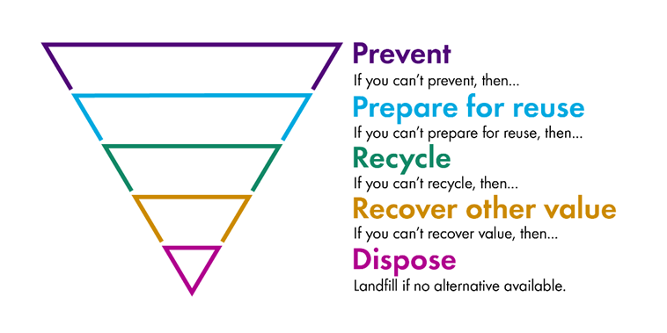

We will measure the amount of waste that we recycle every year, as well as our emissions from waste. By tracking these figures year-on-year, we will be able to measure improvements and identify which waste reduction measures are most effective.

It is challenging to measure our own organisational waste, but we can take proven steps to reduce our waste. Reducing waste begins with procurement, where we have already included the waste hierarchy in our Sustainable Procurement Guidance. We guide employees to procure only what they need and buy goods that can be disposed of responsibly. We then trust our excellent waste management processes to minimise emissions at the end-of-life of goods.

*Communications Objectives: We will communicate the benefits of reducing waste and link reducing waste with more responsible procurement and other performance outcomes. We will connect residents and employees with practical ways to follow the waste hierarchy and improve recycling rates. Residents will understand how to dispose of waste responsibly and how our waste practices align with this imperative.*

## Focus Area: Planning

Building a climate-ready East Lothian will require planning for the effects of climate change. We will improve and increase the number of green spaces in urban environments to help with flooding and fire resistance, and provision spaces for wild spaces and waterways that can help resilience to flooding and fires. We will also locate space for nature-based solutions to adapt to climate threats.

Local authorities can influence up to one third of an area’s emissions through levers such as planning. We will develop guidance that clearly supports renewable energy and sets criteria for developers to align with our sustainability aims. We will encourage the re-use of existing buildings and plan neighbourhoods that are accessible and well-provisioned. Our climate-forward approach to planning will also have a positive effect on our heritage. We will support using existing buildings and natural, local building materials that conserve the character of our region while reducing embodied emissions.

*Communications Objectives: We are looking to conserve the character of our settlements and natural spaces while preparing our area for a climate-affected future. There are co-benefits to be gained by planning responsibly and achieving climate-positive outcomes. Planning decisions will be informed by climate-positive thinking, which is made possible by our improved Carbon Literacy and clearer, locally relevant guidance.*

## Focus Area: Libraries, Parks, and Sports

The spaces that we manage for our communities are among the most important to us, which is why it is critical that these spaces reflect our understanding of climate change and commitment to combatting it. The activities that residents enjoy should be resilient to extreme weather where possible by protecting play infrastructure and sports facilities with nature-based solutions such as rewilded zones and natural drainage systems.

We will deliver these services in a low-impact and resilient way. We will also make sustainable ideas and activities available to residents through these customer-facing services. Many services are already low-impact and compatible with our approach to climate action. For example, libraries support a circular economy, and the enjoyment of outdoor spaces is low- or no-energy. We will continue to encourage residents to reach libraries using sustainable travel. The spaces we offer services will be hubs of renewable energy, energy efficiency and climate resilience.

*Communications Objectives: Libraries are the original circular economy. Residents should feel that libraries are an accessible, climate-resilient space that enables them to access services and enjoy themselves with low or no environmental impact. Users, residents, and staff should access sports facilities and libraries using active or sustainable travel. We should look for and take opportunities to naturalise our pitches and parks to make Council land into climate-positive space.*

## Focus Area: Care

The Council delivers care through the Integrated Joint Board (IJB), which operates in cooperation with NHS Lothian. NHS Lothian manages most of the buildings and some of the services, while the Council operate services, use vehicles, and use goods.

Our partners share our vision for sustainability. We all have a strong desire to work in concert rather than in silos and to deliver effective climate change action. The IJB and its partners will produce a region-leading Sustainability Plan which will address 3 shared priorities: Buildings; Waste; and Travel. Improving climate resilience in these areas is critical for all partners, as patients are likely to be among the most vulnerable to the effects of climate change. It is therefore critical that patients are accessible in extreme weather events and are in spaces that are resilient to extreme weather.

Collaborative action to address these priorities will dovetail with the Council’s activities. Combining our efforts will accelerate emissions reductions in the areas most relevant to the delivery of care in the region.

*Communications Objectives: Care managers should always have a ‘Plan B’ to continue patient care in case of extreme weather. The Council and NHS are aligned in our priorities, and we are confident we can effectively deliver services in a low-cost, low-impact way.*

# Place

Outcome: The county’s environment and communities have a thriving relationship that improves resilience to climate change and reduces emissions.

We recognise the influence we have outwith Council premises. We are the custodians of the people and land that make up East Lothian, so we will help both to be more climate-conscious and climate-ready. The people and environment of our place can be supported to reduce emissions and enhance resilience to climate change.

## Focus Area: Communities

The wellbeing and resilience of our communities is our motivation to take climate action. We must mitigate the devastating effects of climate change and help our communities adapt to a climate-affected world. The Scottish National Adaptation Plan 3 places community resilience as its one of its central themes, so the Council should provide logistical support to make sure that communities can respond to climate-exacerbated weather emergencies.

We will support climate action in spaces and forums that the Council manages. We will also make efforts to empower community climate action by connecting projects with land and funding. This will include initiatives such as community food and energy production, which are improve resilience to climate change and can enhance well-being.

*Communications Objectives: We are working to express more clearly what support there is for community climate action. Communities should feel they are able to access clear, useful, and relevant information about how to be more resilient to climate change. They should also feel that their views on sustainability are valued and there are avenues to express those views.*

## Focus Area: Green & Blue Networks

Our outdoor spaces are treasured by our community. They provide informal play spaces for children, they host tremendous biodiversity, and they provide resilience to effects of climate change such as heat and flooding. The Council manages open and green spaces across the county from the beaches to hills, and these areas need support to retain the qualities that make them so valuable. We will enhance these green spaces, with particular emphasis on areas which provide benefits to climate resilience. We will enhance dunes to combat coastal erosion, enhance water courses to improve water run-off, and plant trees to expand shade cover during heat events. We will also identify and enhance green spaces in built-up areas so there are fewer barriers between ourselves and the environment, expanding nature networks and providing resilience benefits.

We will favour nature-based solutions and look to use green solutions for climate resilience wherever possible. Planting trees and naturalising grasslands will also sequester greenhouse gas emissions from the atmosphere and support nature networks that will help restore the natural world. We will take forward climate action that looks to address the twin climate and nature crises. We will develop a new Local Biodiversity Action Plan that will work in synergy with the Climate Change Strategy to restore the natural environment

*Communications Objectives: We will link extreme weather and other disruption to climate change wherever it is relevant. Press statements and releases will clearly link the twin climate & nature crises. Staff should understand that delivering nature-based solutions has the dual benefit of addressing both crises.*

## Focus Area: Commuting

Staff and agency commuting is one of our ‘stickiest’ source of emissions. It was our second-largest contributor in 2023/24, accounting for 29% of our emissions. We have many front-line, education, and agency staff who must work on-site for service delivery and well-being. Despite this, we must accelerate the fall in emissions from staff commuting to prepare ourselves to achieve net zero by 2045.

Reducing reliance on employee commuting will also mean having a resilient workforce that is more flexible and better able to continue in instances of severe weather and flooding.

We must also develop an approach to encourage less and more sustainable commuting outwith the county. Many residents work in larger cities and commute via private car journeys, so we should encourage moving to active, shared, or sustainable travel options.

*Communications Objectives: We understand why our commuting emissions are higher than previously thought and what that means for the overall emissions of our organisation. Staff go from ‘I should travel sustainably to work’ to ‘I will travel sustainably to work.’ Residents are aware of the work we are doing that makes it easier to travel sustainably and take advantage of these schemes.*

## Focus Area: Economy

The East Lothian Partnership’s Community Wealth Building Charter is the only such document to include climate change alongside the other 5 community wealth building pillars. We will progress the actions in this pillar alongside our fellow anchor institutions, NHS Lothian, Edinburgh College, and Queen Margaret University. We will also make progress on our Poverty Plan to reduce inequalities in the county. Communities with high levels of wellbeing are more resilient to climate change and more empowered to take climate action, so achieving this aim will support the county to be more climate positive. We will also aim to have more climate-positive businesses in East Lothian and grow the number of workspaces, which has the co-benefit of less commuting. We will also look to upskill, reskill, and future-proof East Lothian’s workforce so that residents can find secure, climate-positive jobs and we can procure local firms to support our climate change actions.

*Communications Objectives: Local businesses and prospective business owners are aware of the avenues of support we offer to improve sustainability. The sustainability advice we provide is relevant, attractive, and is accessed more often. Businesses are aware of how climate change will impact them and are motivated to take action. Staff see links with community wealth and climate-positive outcomes, and residents can identify instances where our climate action has addressed poverty and built community wealth.*

## Focus Area: Homes

East Lothian has a mixed housing stock. It is one of the fastest-growing counties in terms of house-building, but it also has an irreplaceable and nationally important heritage. We must balance the demand for new housing reflected in the national housing emergency with the need to conserve existing communities.

New homes are usually more energy-efficient than existing ones and often are powered at least in part by renewable energy. We will therefore aim to improve the energy efficiency of existing housing stock and increase the number of homes that are heated or powered by renewably generated electricity. We are exploring non-gas heating solutions for all our affordable housing. We will also use our planning powers to site new housing in climate-resilient or –adaptable locations and build neighbourhoods that are accessible by public transport to reduce reliance on private car journeys.

*Communications Objectives: Staff and residents understand that using water and energy more efficiently has the dual benefit of lowering emissions and improving resilience. We are emphasising the importance of using existing homes to address the national housing emergency while keeping embodied carbon to a minimum. Staff and residents understand that electrification is a long-term decarbonisation solution, while gas is cheaper in the short term but cannot be decarbonised.*

# Monitoring & Reporting

The Climate Change Strategy 2025 – 2030 has over 150 actions, all with quantitative performance indicators. Updates on these actions will be collected from the respective action holders annually. A summary will then be presented in a master spreadsheet to elected members alongside the latest emissions data in the first quarter of each calendar year. Progress on each action will be colour-coded and compiled into a Gantt chart to enable an at-a-glance check of the Council’s climate actions.

The results of the annual action updates will be reported to an officer group (CNEG), to Audit & Governance committee, and to Cabinet. All will be publicly available in Members Library reports and linked to on the Council’s climate change web page.