Young Carers Survey on ID Cards

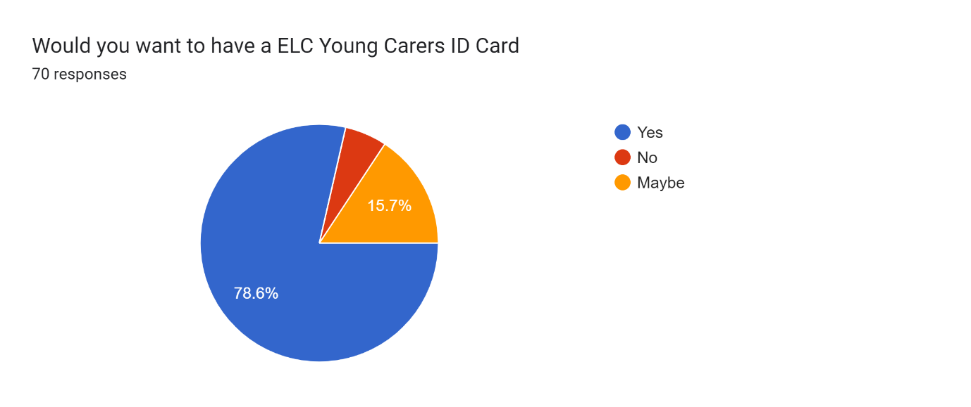

Comments overview
50% of those saying YES left a comment. The majority stated that it was a great idea, giving Young Carers recognition.
82% of those saying MAYBE left a comment. They majority of these left it would be great if it also offered Young Carers some discounts as well as being a recognition card.
66% of those saying NO left a comment. The majority did not want to risk the Break from Caring Programme being affected.
YES comments
This is a great idea
It would help collecting my mums tablets and been able to show the school I am a young carer
This would be a helpful tool for young careers to be able to identify them selves and feel more confident in situations when discussing that they are caring if they do not want this to be a known thing
I think those a brilliant idea for children to prove they are carers
Would help so much
This would help enormously
I think it is a good idea and would be happy to contribute the cost so it did not eat up so much of the budget.
I think this is a good idea
I think it would be a good thing for the kids to have, especially if it could get them discounts at attractions etc. It would make them feel a bit more important and recognised as a carer.
I'm happy to pay the money for my son to have one.
This will help people understand that we are doing an important role in helping look after someone
It would be useful to have if it worked for getting discounts or ID for getting prescription.
I’d be happy to pay the cost of my daughters cards, to save money that can be used elsewhere to benefit the children
Excellent idea. It helps promote caring as part of their identity and adds a sense of pride and validation that they play an important role.
Be good for L to get out about and do things he's not done before
I would be happy to pay the £4 towards it
What about the possibility of parents paying the £4 for the card to save eating into your funding? I would happily do this.
I think the card would be seen by young carers as part of growing up and being more reliant than your standard young person. Almost like recognition they are a young carer.
I would be happy to pay for the card myself
I would be happy to pay the £4 myself
Providing that we pay for the card and this isn’t taken from your budget.
If it gets discounts and allows me to pick up prescriptions, that would be great
Certainly very useful for prescription collection and other places where young people are barred from at certain times due to unruly behaviour by a few
I believe this would benefit the young carers a lot and the fact thaf hppfully kne day they can use thr card as a way of I'd for discount for attractions as well is fantastic news
I think this would be a great idea
I think this would be a very positive thing
Great idea and needed in east Lothian. England and some part of Scotland already using it and it seems to work.
It gives ID to the person related to the card and shows what they do caring in the community.
Just think it would be a good idea
MAYBE comments
Might be useful if discounts for Young Carers became more widely available but at the moment, the cost seems prohibitive.
Great idea, but does seem a lot out of the budget, for those who could afford a small donation towards it, that would maybe help to keep the costs down??
Cost to have card would need to have perks to legitimise cost which could be more locally based compared to Young Scot card and more open to under 16s than some existing reward cards etc. That would take time to develop so perhaps more clarity around the benefit of a card being produced compared to business card (not smart card) for things such as pharmacy collection authorisation. (Could also be a letter from Young Carers of East Lothian on a letterhead. Not so robust but much less expensive to produce / replace if required).
Alternatively - seeking funding for this particular initiative through something like a cross-county application to the Area Partnerships? £500 from Musselburgh and £300 from each of the other 5 given population sizes as a rough guide. (May need a more data driven breakdown for each area based on percentages of young carers from each Ward).
How about we pay for the card ourself? I like the idea, not sure when we would actually use it (maybe when swimming, but we do have a key fob with those details).
Children need breaks away from caring, if this interrupts trips for them to have fun and be a child then I’d be against it
It would be great if your logo could just to be added to the existing smartcards for young carers to show at any relevant events or for entry to attractions etc. A separate card seems silly when these are already in place for free bus travel. It's a shame you have to take the financial hit. I would have no problem paying the £4
I am not sure that my child needs one yet, but I can see that it may be beneficial to have one as she gets older and might be likely to take on more responsibilities.
I would have for the cost of this to impact on trips for young carers, so I would be happy to pay the £4 to cover costs.
NO comments
rather have activities
rather have more activities
As many children have various cards eg young Scot’s card , library card & Eastlothian leisure card I feel yet another card to keep when they have all them ? Not sure they need another id card x

