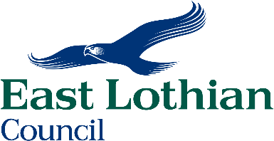
SUMMARY OF PRINCIPAL TERMS OF APPOINTMENT

Head of Service

This post is subject to the terms and conditions of the JNC for Chief Officials in Scotland and the local decisions of East Lothian Council as adopted and amended from time to time, through either collective or individual contractual agreement.

Salary Chief Officer Scale - SCP 37 currently £105,487 per annum

Hours of Work 37 hours per week

Annual Leave 28 days plus 8 fixed and 4 floating General & Public Holidays

Sickness Allowance The scheme provides for 5 weeks full pay and 5 weeks half pay rising to 26 weeks full pay and 26 weeks half pay dependent on reckonable local authority length of service.

Superannuation The Local Government Superannuation Scheme is a contributory scheme known as a career average salary scheme, benefits being related to earnings and service. The Council guarantees that your benefits will be paid.

Medical Screening All appointments are subject to medical screening by the means of a self-completion questionnaire scrutinised by the Council’s Occupational Health Service.

Trade Union Membership Employees have the right to join and take part in the activities of an appropriate trade union and are encouraged to do so.

No Smoking Policy It is Council Policy that smoking is not permitted at work.

Politically Restricted This post is designated as a politically restricted post under the Local Government and Housing Act 1989 with a restriction on public political activities

Complaints The Council has a Feedback Policy, which includes the consideration of complaints. All applicants have access to it if they feel they have been unfairly treated during the recruitment and selection process. Internal applicants should direct any concerns through the Council's Grievance Procedure.

Other Employee Benefits An example of some of the additional employee benefits the Council offers include. Salary sacrifice schemes for Cars, Pension AVC’s and Cycle to work scheme. Employee Assistance Program, access to physiotherapy, massage, podiatry, Credit union, Pool cars, etc

East Lothian Council is an equal opportunities employer and will prevent discrimination particularly on the grounds of sex, marital status, disability, race, colour, sexual orientation, trade union activity, religious belief, political belief, nationality, ethnic origin, age, responsibility for dependants or employment status.

